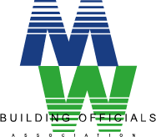
Provider No.1225 Course No.

Metro West Building Officials Meeting

May 15, 2018
9:00AM ‐ 12PM
Place: Westborough Town Hall Memorial Room 2nd Floor
34 West Main Street Westborough, MA 01581

This month’s presentation will be on:

2015 Swimming Pool and Spa Code presented by
State Building Inspector Gene Novack

"INTRODUCING THE 2015 ISPSC"

"The goal of the seminar is to high light the 2015 ISPSC"

We will cover items including but not limited to the following:

Code Book Layout
Classification of Pools
Mechanical Requirements
Barrier Requirements
Emergency Shut Off
Energy
Accessibility
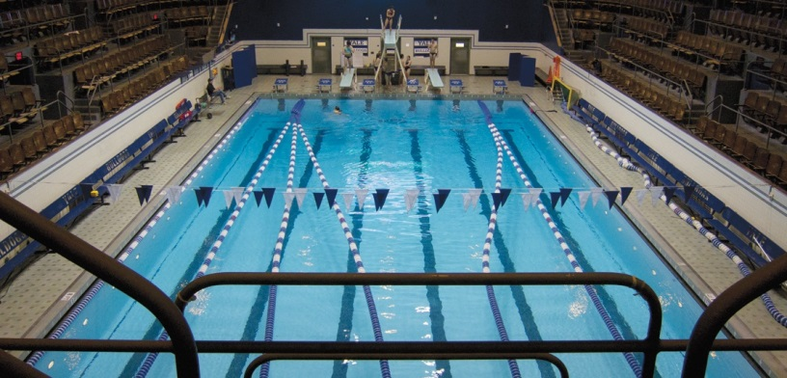
Eugene "Gene" M. Novak, Jr., CBO
District State Building Inspector
Department of Professional Licensure
Office of Public Safety & Inspections
617-590-3943
gene.novak@state.ma.us
Any questions please call: Robert S. Berger President
Metro West Building Officials Association Inc. (508) 414-8986
Robert.Berger@mwboa.org

